Page 1
Logo
Asherah Villas
Discover redefine serenity
Page 2(back ground color choose by Dan)
The story of Asherah
Asherah--Numerous ancient sources mention the goddess Asherah who is represented by, ‘The Tree of Life’. According to ancient Semitic religion, she is regarded as the queen of heaven and the mother of the gods. She is known as the queen who walks on water because she embodies the spirit of the sea.
page 3
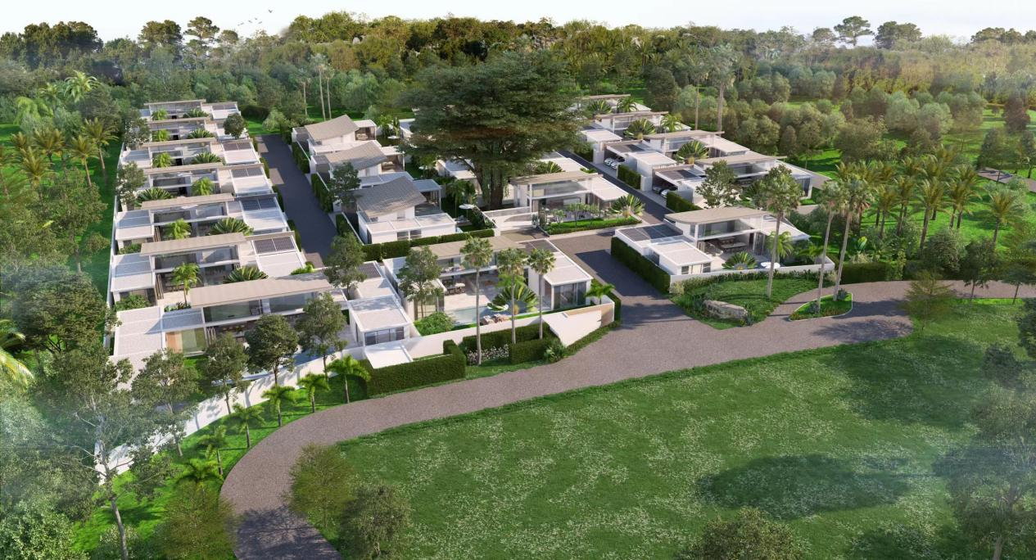

Page 4 (back ground color choose by dan )
Project information
Asherah villas are located at the scenic Centennial Banyan Tree. The total land area of the project is 11,200 square meters. Constructed will be 20three/four-bedroom single-story pool villas. The size of individual villas will range from 405 to 643 square meters.Construction size will be 306 to 458 square meters ,interior size will be start from 170 square meters .
Page 5 (exterior 2-4 photos, if not finished yet ,can add later )
May your heart and spirit reside at Asherah Villas, where the combination of wind, light, wood, and a lush green space creates a majestic surrounding for relaxation, comfort, meditation and creativity.

Page 6 interior (7photos )

"Wood & Green”
The interior design captures the culture and customs of Thailand. From sleek architectural lines to ingenious landscaping and decoration;
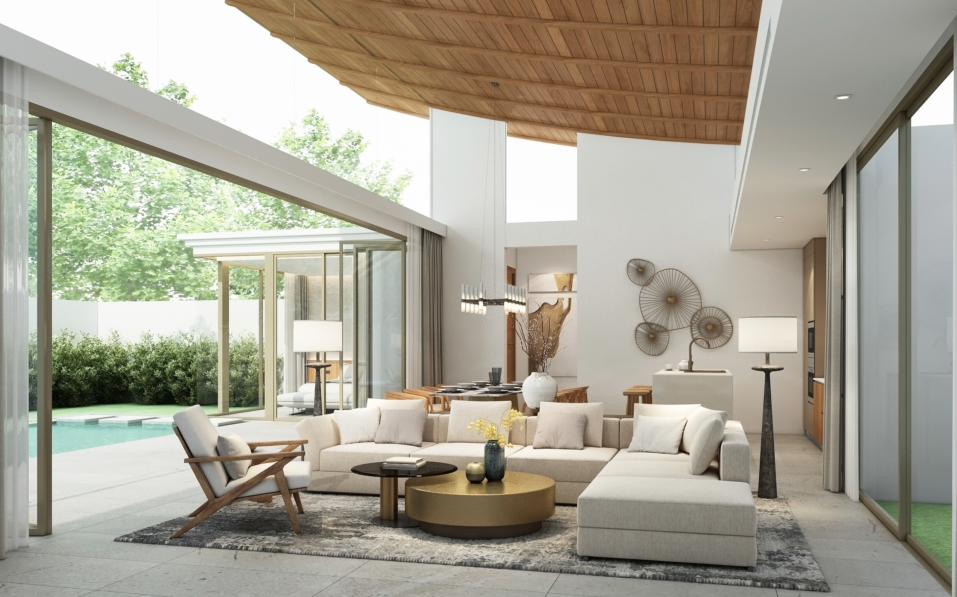
the combination of flora with natural lighting creates light and shade for your front and rear courtyards.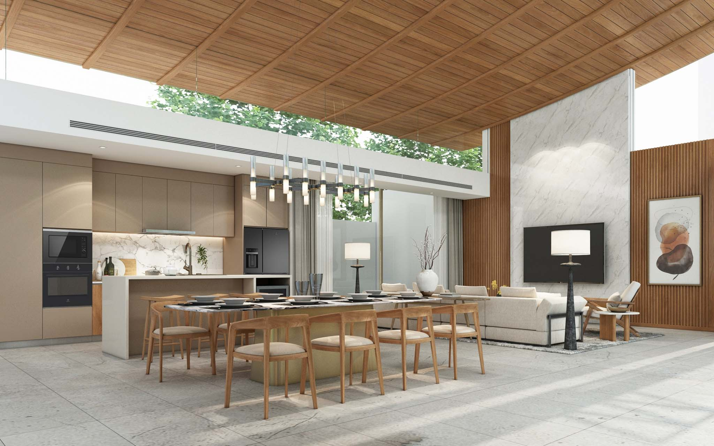All the while highlighting the natural beauty of your surroundings and island lifestyle.
Enjoy the comfort and tranquility provided by spacious home and beautifully landscaped surroundings.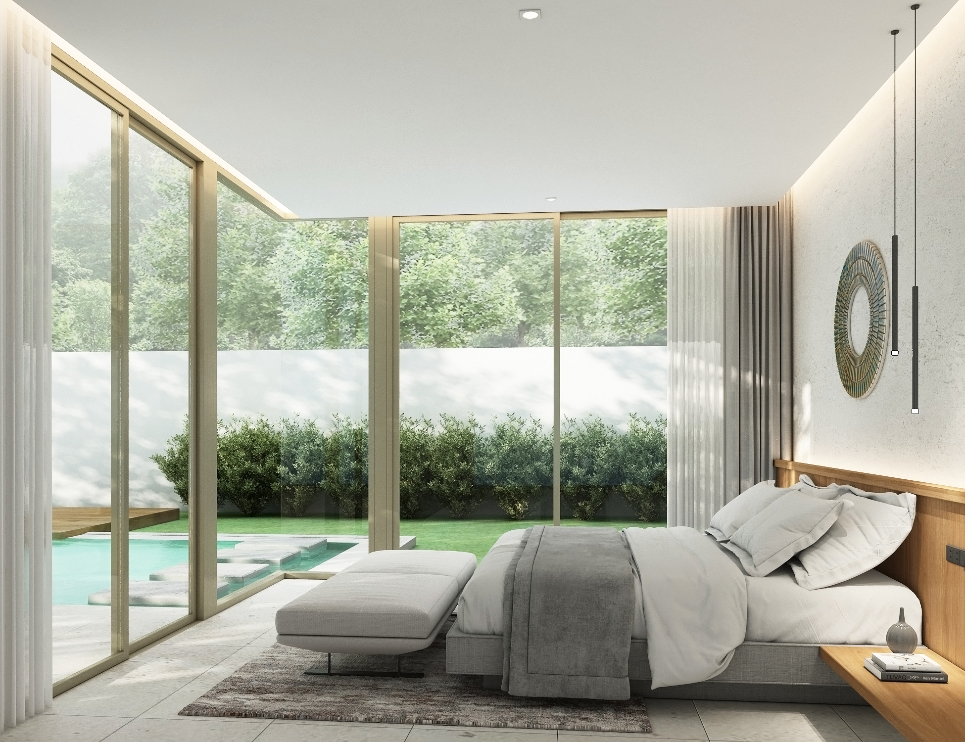 Here you will find the harmony between modern design and the peacefulness of nature.
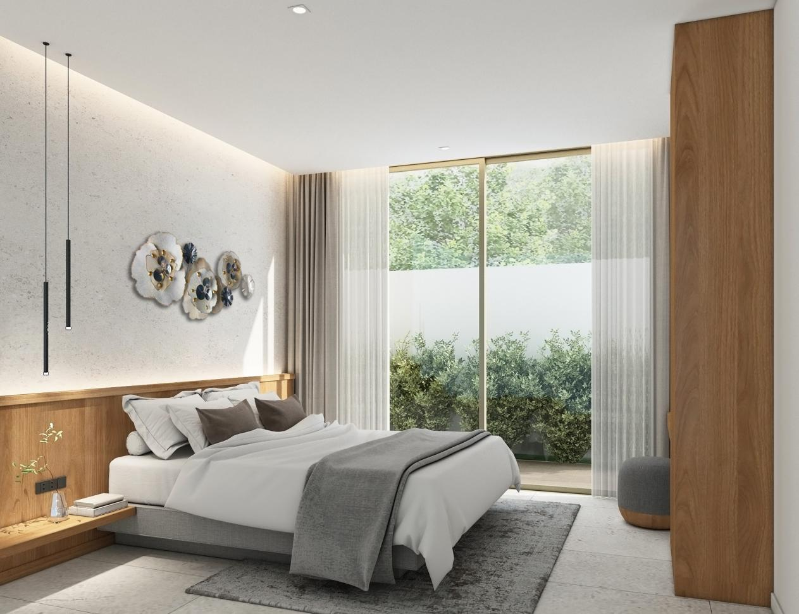
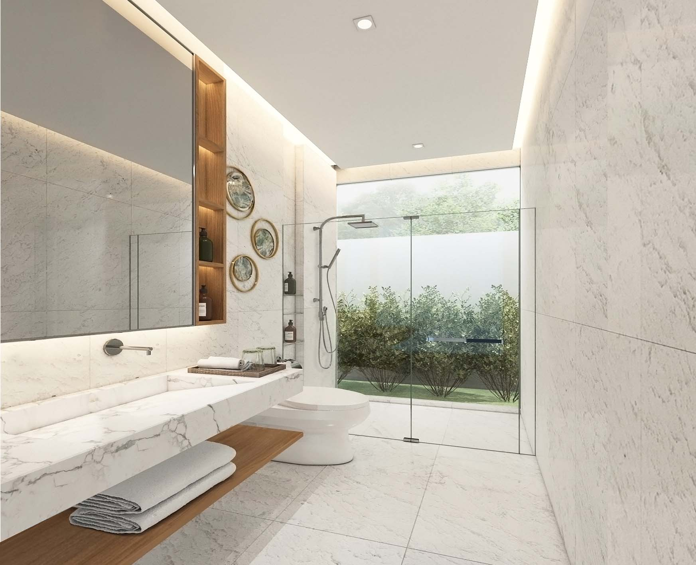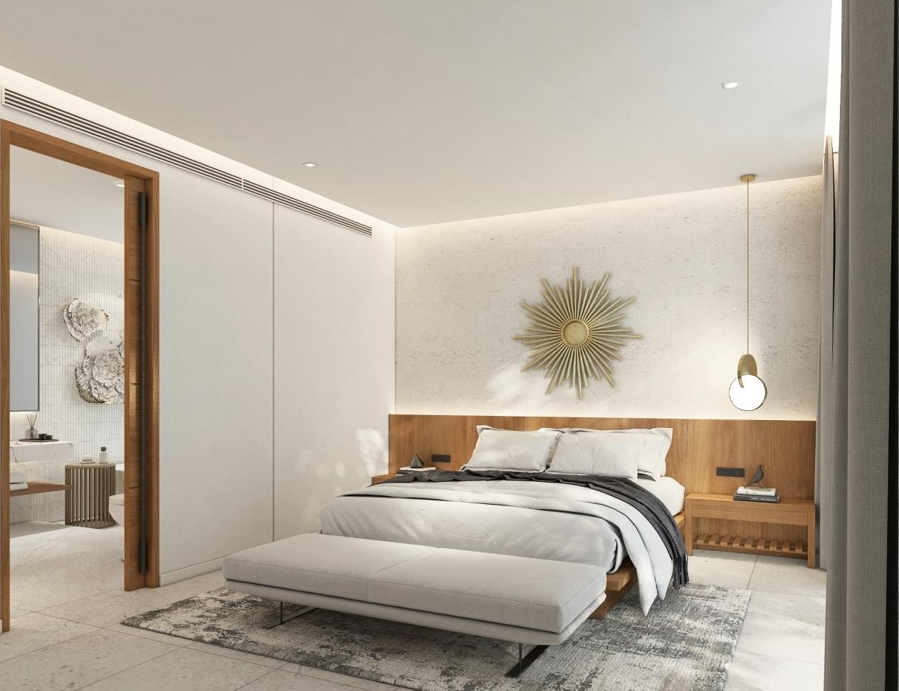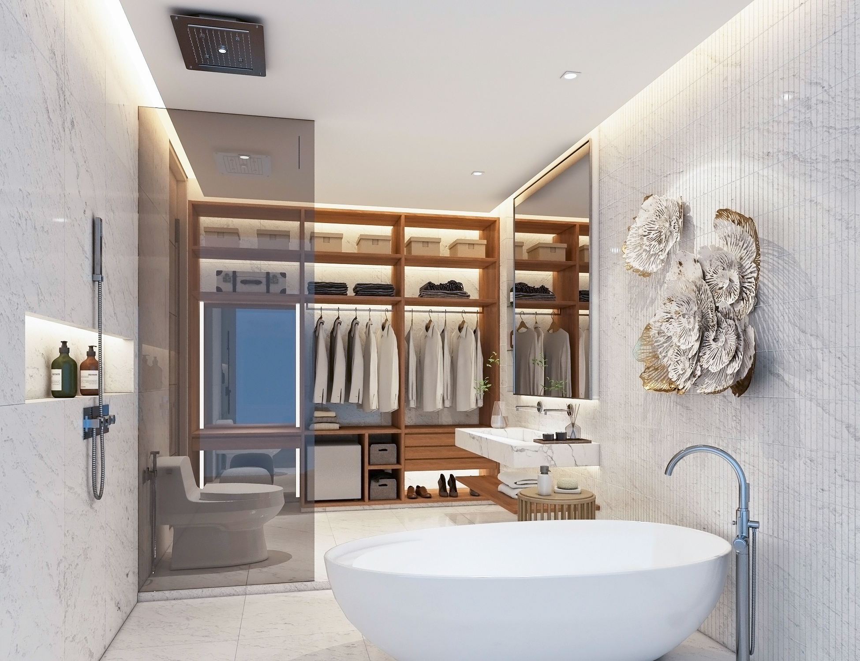
Page 7 (master plan )
Project plan
Project name: Asherah villas
Developer: Thai molman real estate.,Co Ltd
Total Land area: 11200sqm
Number of Units: 19
Title: freehold/lease hold
Villa type : 3&4 bedroom pool villa
Plot size :405-643sqm
Construction size:306-458sqm
Facility & Service :
24hour Security / 24 hour CCTV / villa services /solar power system / water filtration system/villa rental management
Construction term:2022/9--2023/12

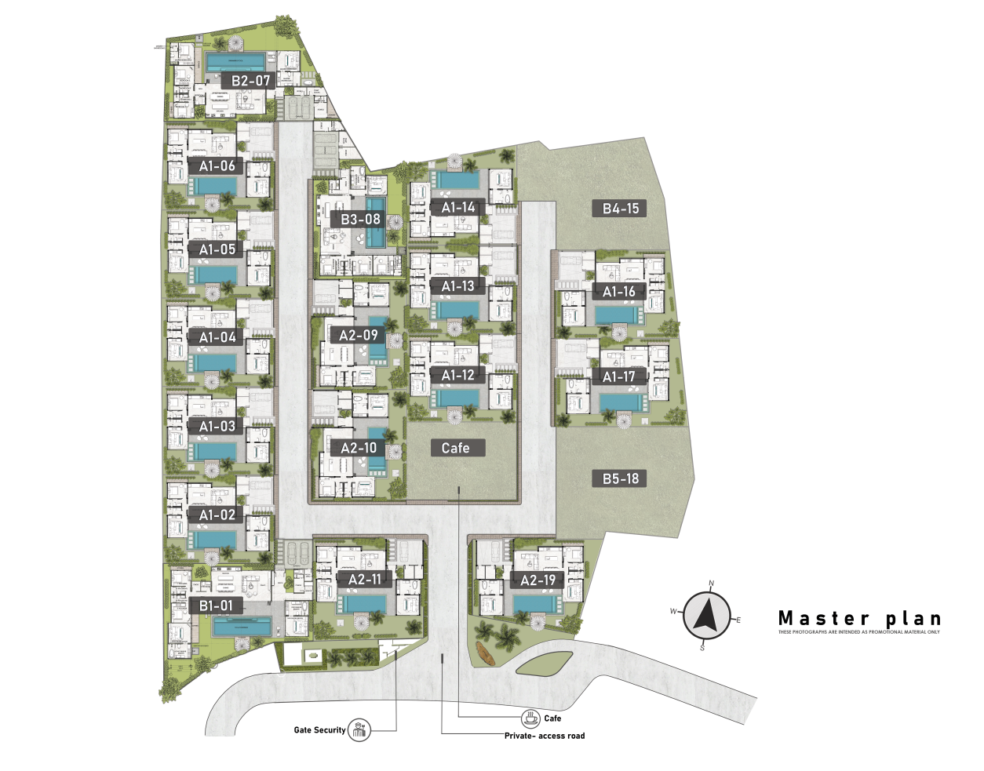
Page 8 floor plan ( photo from A 1-B5)
Page 9 location (map photo)
Asherah Villa is located in the popular northern part of Phuket, near the popular and affluent area Laguna.
A short drive away from Asherah Villas are the beautiful beaches of Bang Tao and Layan. Asherah Villas are also in close proximity to Laguna Golf Club, water parks, shopping malls, restaurants, cafes, convenience stores, international schools, night markets, and beach clubs. The carefully selected location of the project ensures you and your family the convenience and comfort for a blissful life on Phuket Island.

Lifestyle:
Pharmacy 5 mins
7-11/family mart 5 mins
Boat pattya 8 mins
Villa market 8 mins
Central Mall 10 mins
Boat avenue 10 mins
Airport 15 mins
Internet-famous restaurant
Artisan 5 mins
Ma doo bua 5 mins
Origami cafe8 mins
Suay 15 mins
Entertainment:
Laguna Golf Course 5 mins
Mission Hills Island Golf Club 15 mins
Blue Canyon Golf Club 15 mins
Equestrian Club 8 min
Bang Tao and Layan Beach 10mins
Dream beach club 10 minutes
Catch beach club 18 min
Education:
British International School Head Star north campus 10 mins
American International School UWC12 mins
Medical:
Bangkok Hospital 30 mins

Page 10 video (if have )
Page 11 contact

